**CSE523** Machine Learning

Project: Shipment Price Prediction

Weekly Project Report: February 11, 2023

Team: **Revolution**

| Team Members | Enrolment-ID |
| --- | --- |
| Deep Patel | AU2040250 |
| Roshni Navdiya | AU2040114 |
| Aditya Padhariya | AU2040151 |
| Keval Parmar | AU1940133 |



* **Task Performed this week:**

1. Understanding & Researching the problem statement.
2. Learning and studying about implementing our data.
3. Learning about the models, libraries, and algorithms.

* **Outcomes of the tasks performed:**

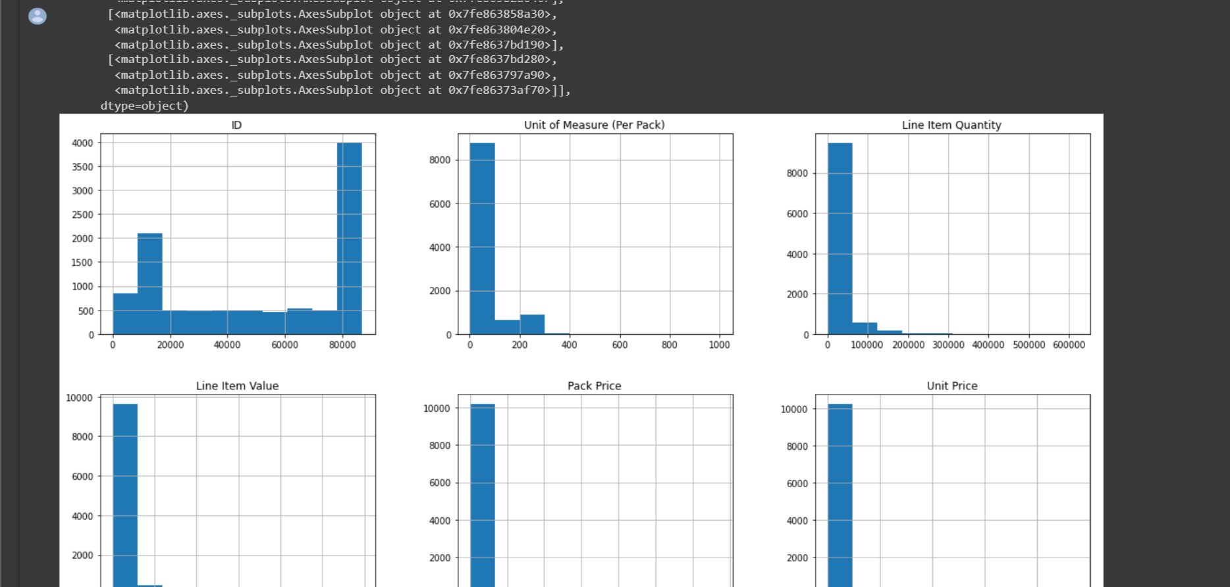

1. Analysed the parameters.
2. Understand the dataset of Shipment Analysis.

* **Tasks to be performed in the upcoming week:**

1. Exploring and trying to implement different models and algorithms that can be used further with our dataset.
2. Pre-processing of dataset.